<https://www.udemy.com/course/angular-7-a-quick-start-guide/learn/lecture/13697714#overview>

<https://www.udemy.com/course/build-awesome-web-apps-using-angular-7/learn/lecture/12940710#overview>

<https://www.youtube.com/watch?v=3oNZrdZUpnA>

---------------------------------------------------- instalacje ---------------------------------------------------------------

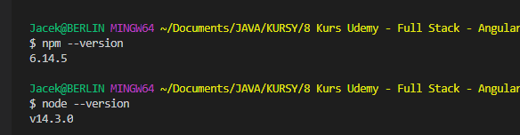

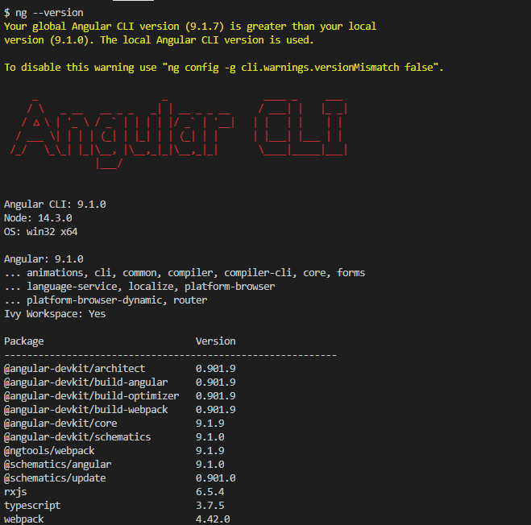

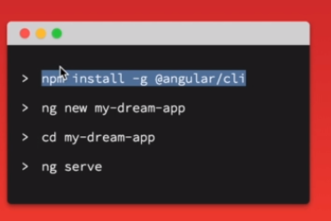

------------------------------------------------------------------------------------------------------

lokalny PATH:

C:\Program Files\MySQL\MySQL Shell 8.0\bin\;C:\Users\Jacek\AppData\Local\Programs\Microsoft VS Code\bin;**C:\Users\Jacek\AppData\Roaming\npm;C:\Program Files\nodejs\**

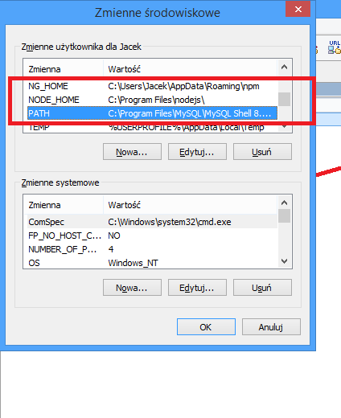

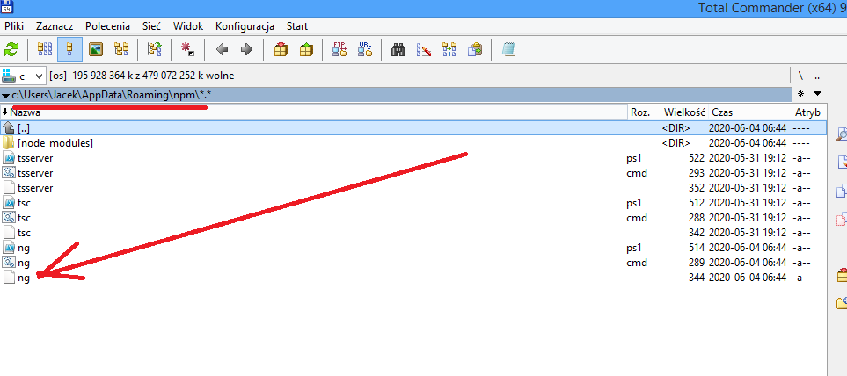

----------------------------------- tworzenie angulara ---------------------------------------------------------

instalacja pakietów pakietów angulara:

przechodzimy do katalogu z aplikacją:

c:\Users\Jacek\Documents\JAVA\KURSY\8 Kurs Udemy - Full Stack - Angular and Spring Boot\ecommerce-project-release-2.8.sekcja19\12-frontend\

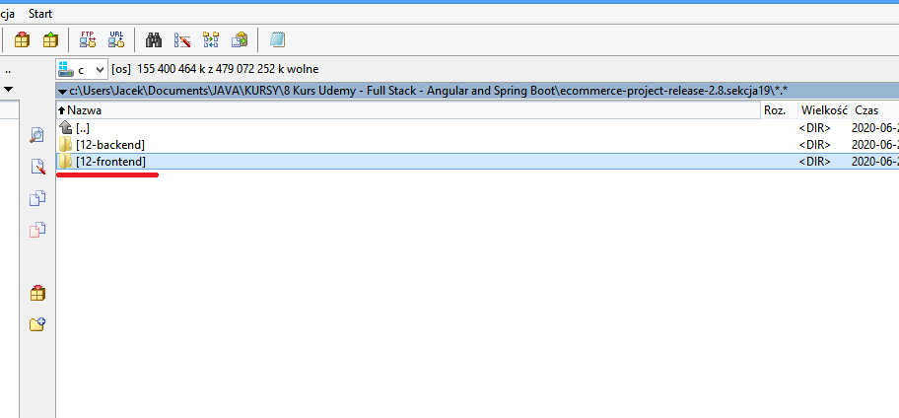

1. instalacja pakietów angulara:

npm install -g @angular/cli

----------------------------------- tworzenie projektu ---------------------------------------------------------

cd c:\Users\Jacek\Documents\JAVA\KURSY\8 Kurs Udemy - Full Stack - Angular and Spring Boot\ecommerce-project-release-2.8.sekcja19\12-frontend

1. ng new ecommerce-project-release-two-eigth

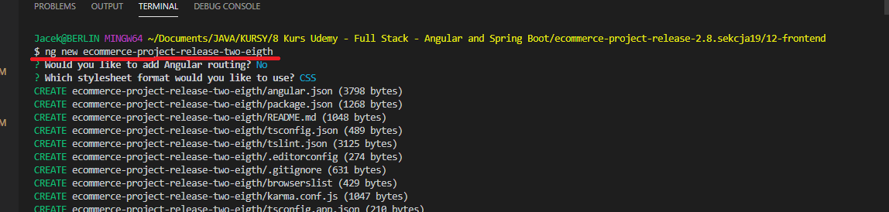

cd c:\Users\Jacek\Documents\JAVA\KURSY\8 Kurs Udemy - Full Stack - Angular and Spring Boot\ecommerce-project-release-2.8.sekcja19\12-frontend\ecommerce-project-release-two-eigth

2. kompilacja i uruchomienie nowego projektu

ng serve

lub

npm start

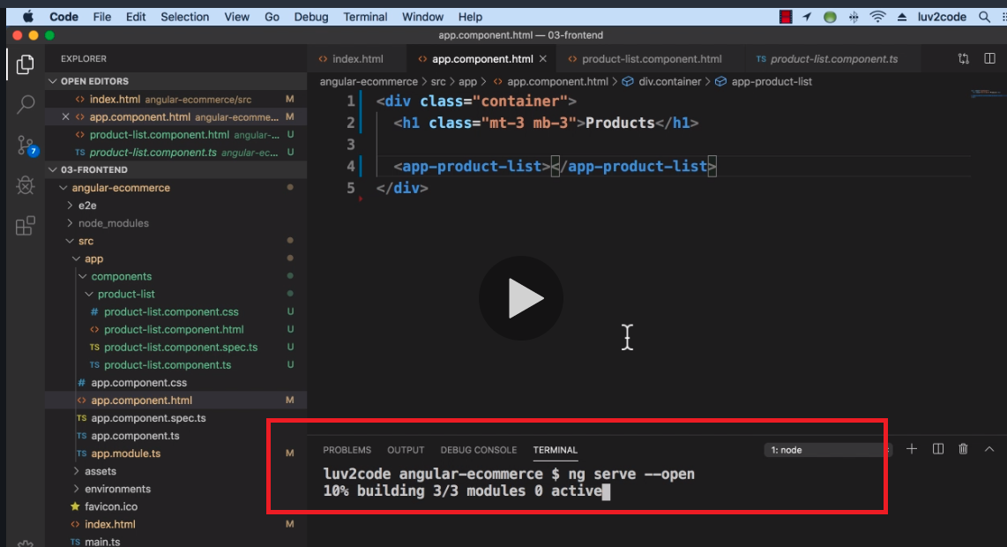

3. instalacja bootstrapa:

https://www.udemy.com/course/the-complete-guide-to-angular-2/learn/lecture/6655614#overview

npm install --save bootstrap@3 (instaluje w lokalnym projekcie - nie globalnie)

lub

npm install bootstrap

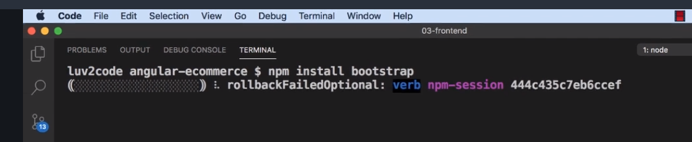

to dodajemy w pliku angular.json w 2 sekcjach styles[...]

"node_modules/bootstrap/dist/css/bootstrap.min.css",

    "styles": [

              "node_modules/bootstrap/dist/css/bootstrap.min.css",

              "src/styles.css"

            ],

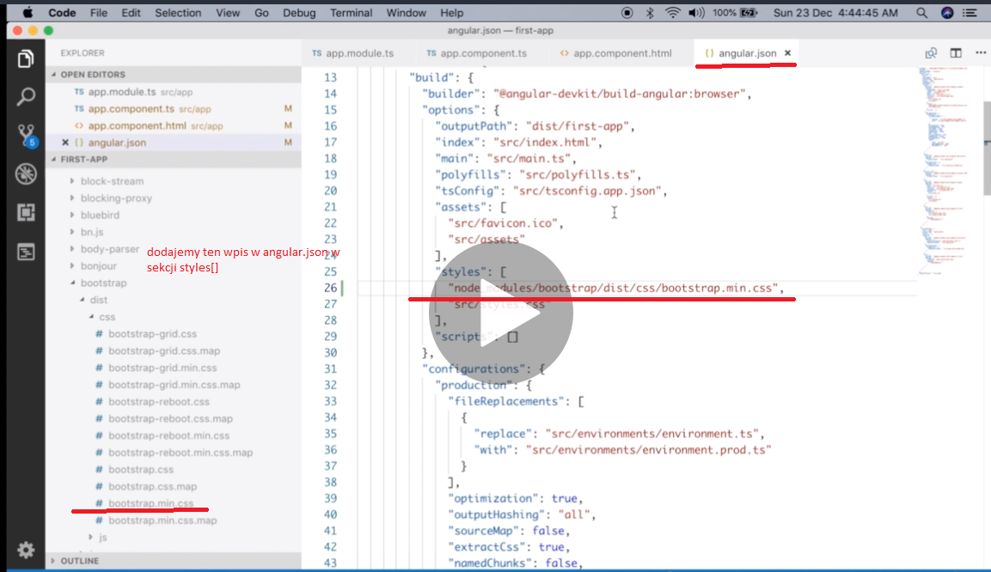

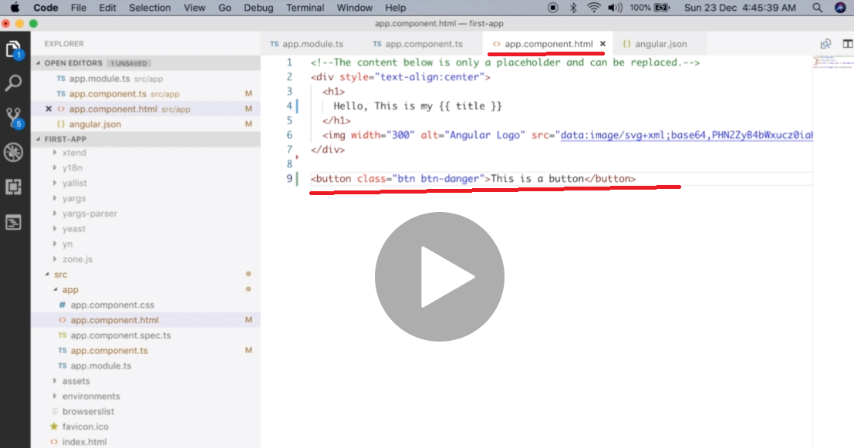

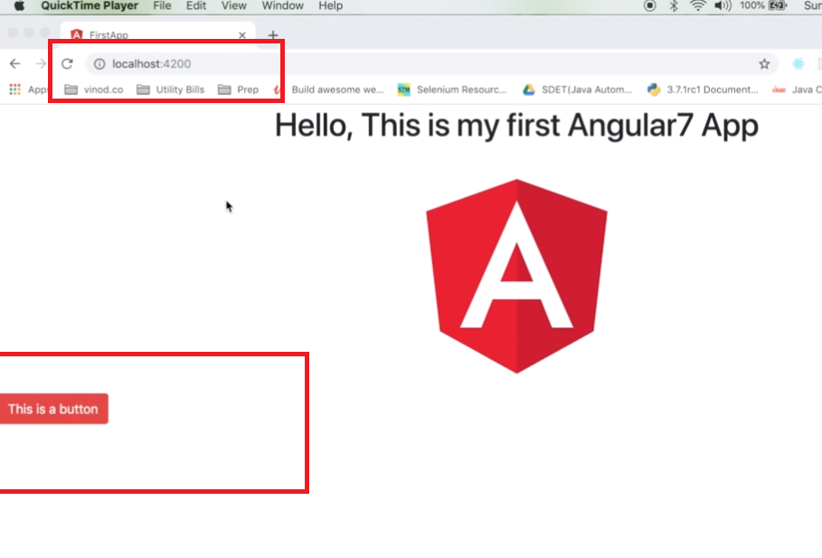

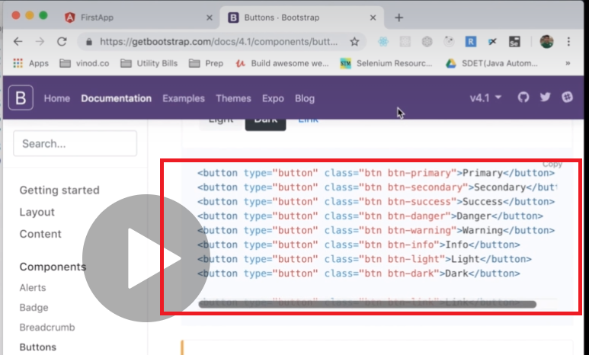

usuwanie bootstrapa:

npm uninstall bootstrap --no-save

4. Instalacja ng-bootstrap (pagination):

**krok: 1**

**npm install --save @ng-bootstrap/ng-bootstrap**

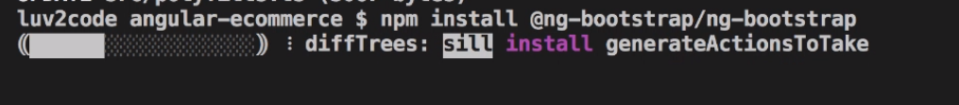

**krok: 2**

**ng add @angular/localize**

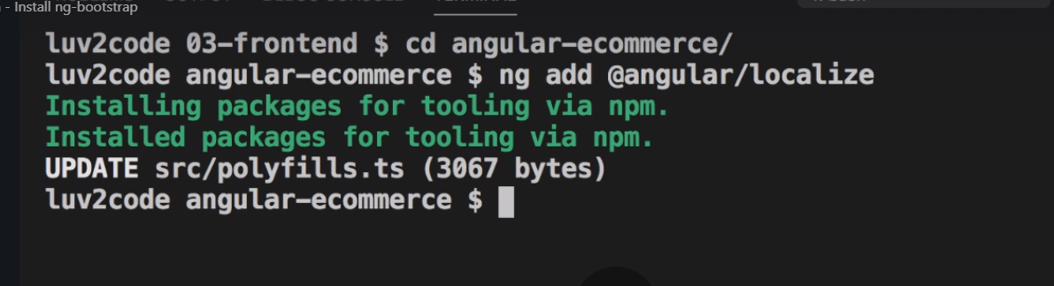

**krok: 3**

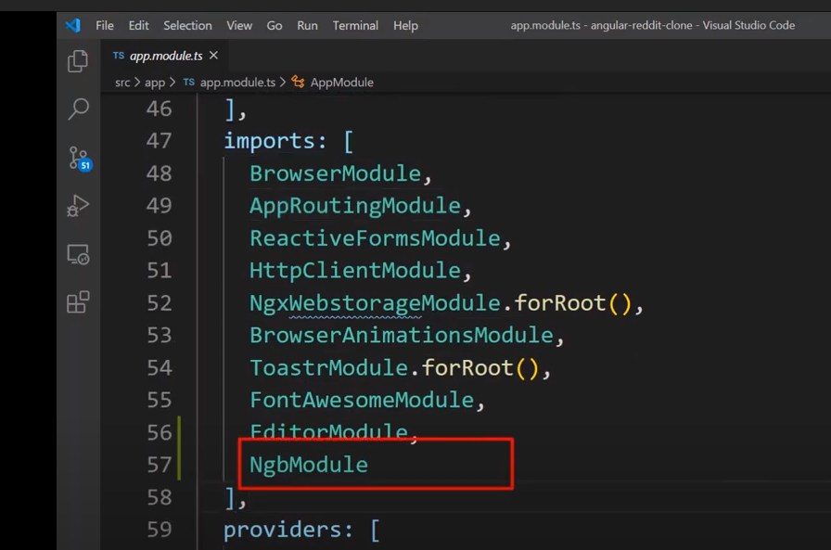

5. instalacja różnych ikonek: fontawesome icons (+/-) and other icons

npm install @fortawesome/fontawesome-free

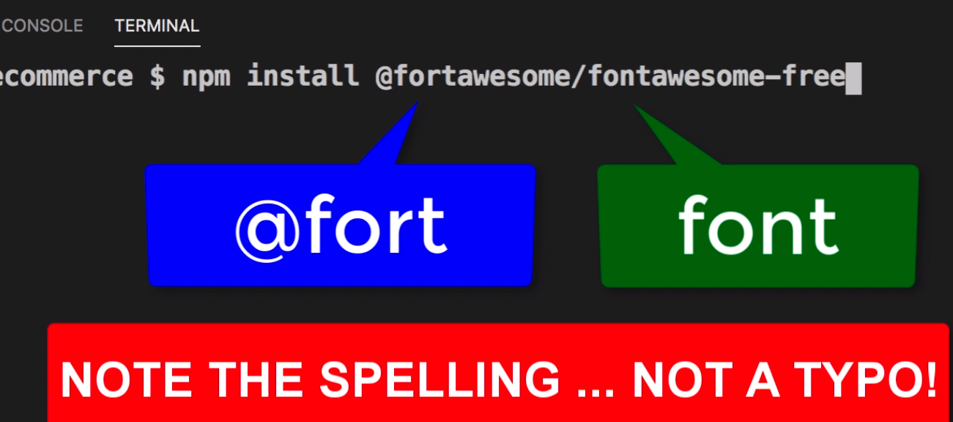

6. Sprzątanie:

npm audit fix

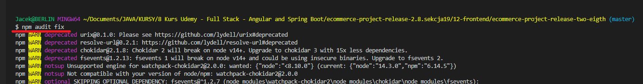

7. Instalacja JQuery **(for pagination on scroll)**

https://www.udemy.com/course/build-awesome-web-apps-using-angular-7/learn/lecture/12953274#overview

$ **npm install jquery @types/jquery**

npm WARN @ng-bootstrap/ng-bootstrap@7.0.0 requires a peer of @angular/common@^10.0.0 but none is installed. You must install peer dependencies yourself.

npm WARN @ng-bootstrap/ng-bootstrap@7.0.0 requires a peer of @angular/core@^10.0.0 but none is installed. You must install peer dependencies yourself.

npm WARN @ng-bootstrap/ng-bootstrap@7.0.0 requires a peer of @angular/forms@^10.0.0 but none is installed. You must install peer dependencies yourself.

npm WARN @ng-bootstrap/ng-bootstrap@7.0.0 requires a peer of @angular/localize@^10.0.0 but none is installed. You must install peer dependencies yourself.

npm WARN optional SKIPPING OPTIONAL DEPENDENCY: fsevents@2.1.3 (node_modules\fsevents):

npm WARN notsup SKIPPING OPTIONAL DEPENDENCY: Unsupported platform for fsevents@2.1.3: wanted {"os":"darwin","arch":"any"} (current: {"os":"win32","arch":"x64"})

npm WARN optional SKIPPING OPTIONAL DEPENDENCY: fsevents@1.2.13 (node_modules\watchpack-chokidar2\node_modules\fsevents):

npm WARN notsup SKIPPING OPTIONAL DEPENDENCY: Unsupported platform for fsevents@1.2.13: wanted {"os":"darwin","arch":"any"} (current: {"os":"win32","arch":"x64"})

npm WARN optional SKIPPING OPTIONAL DEPENDENCY: fsevents@1.2.13 (node_modules\webpack-dev-server\node_modules\fsevents):

npm WARN notsup SKIPPING OPTIONAL DEPENDENCY: Unsupported platform for fsevents@1.2.13: wanted {"os":"darwin","arch":"any"} (current: {"os":"win32","arch":"x64"})

+ jquery@3.5.1

+ @types/jquery@3.5.1

added 3 packages from 24 contributors, removed 2 packages and audited 1598 packages in 61.268s

58 packages are looking for funding

run `npm fund` for details

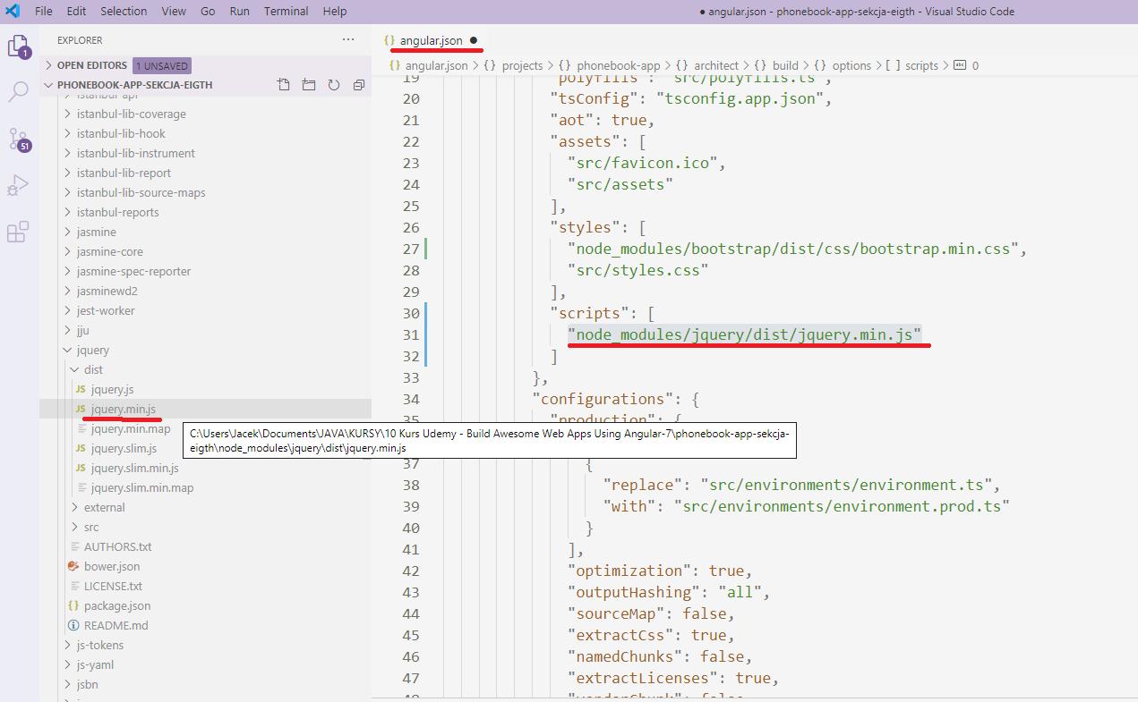

            "scripts": [

              "node_modules/jquery/dist/jquery.min.js"

            ]

można sobie testować: jquery scrypty:

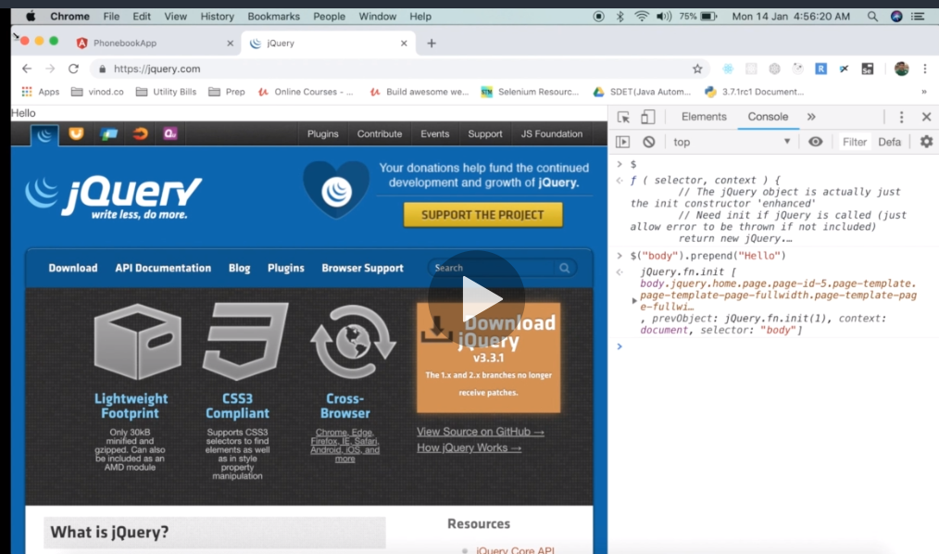

---------------------------------------- development aplikacji -----------------------------------------------------------

tworzenie nowej klasy:

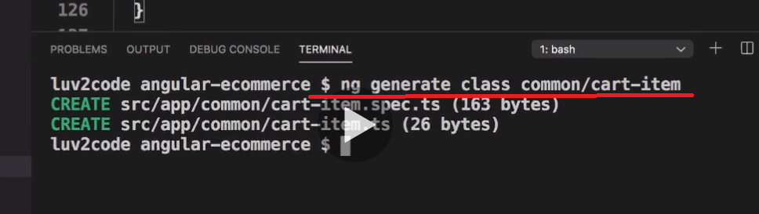

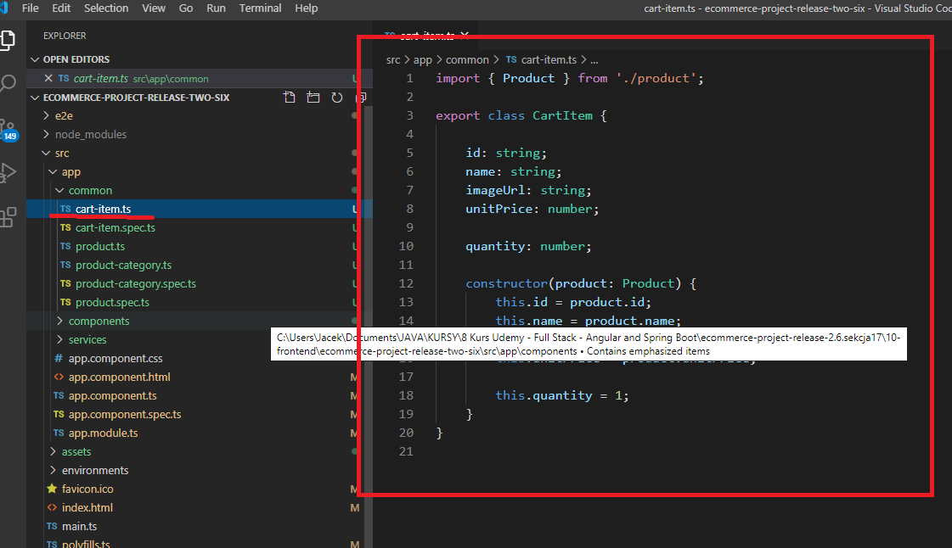

Tworzenie nowego serwisu (usługi):

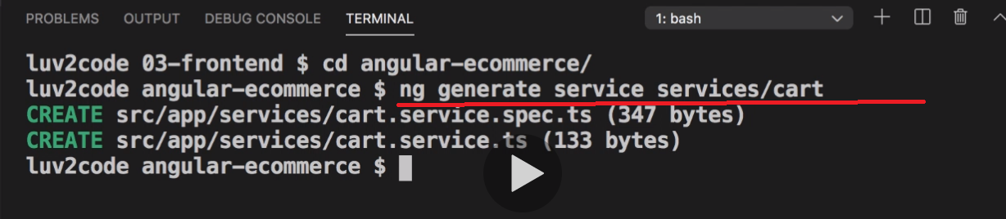

skrótami:

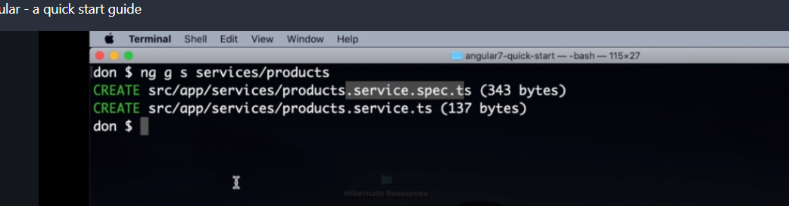

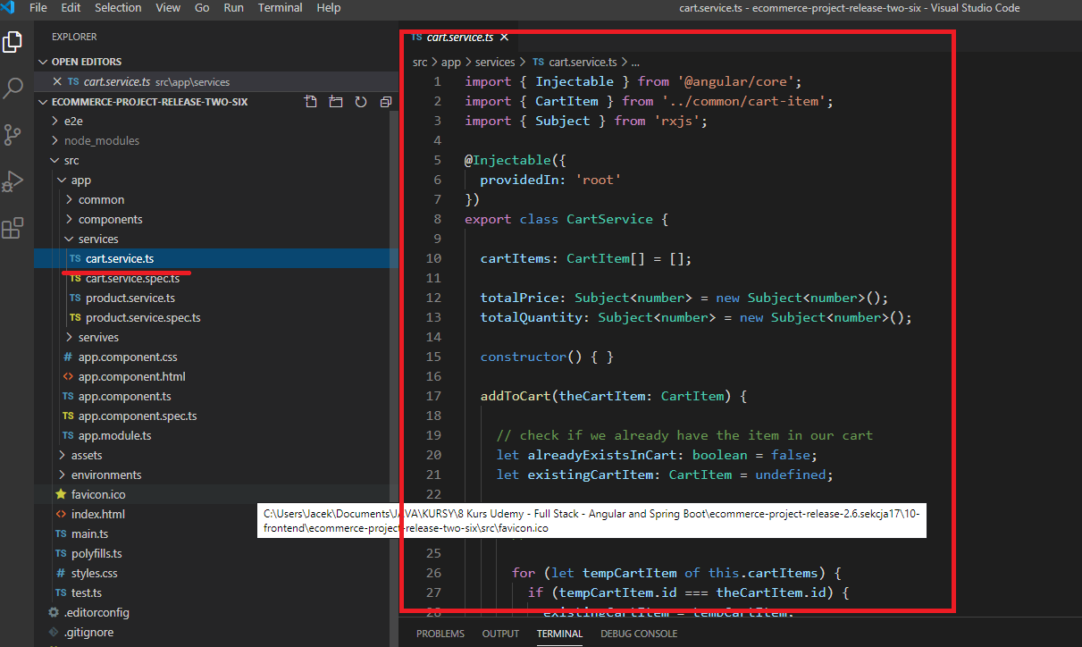

Tworzenie nowego directives:

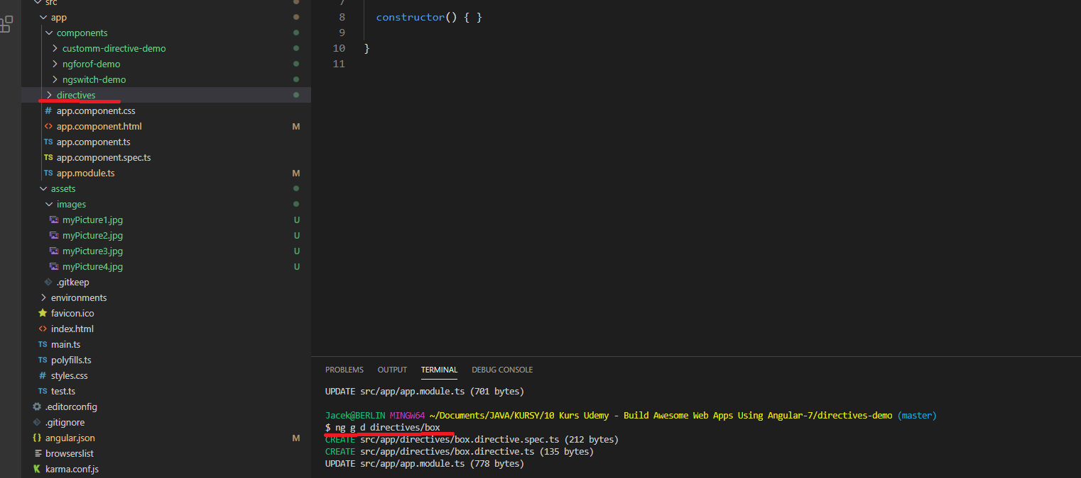

Tworzenie nowego komponentu:

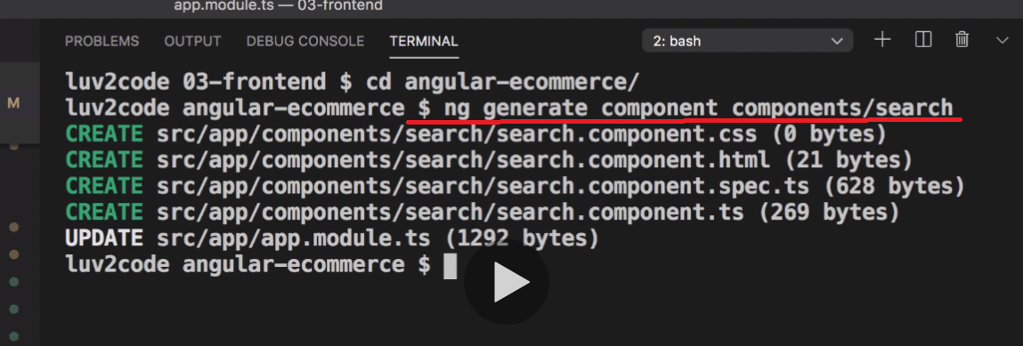

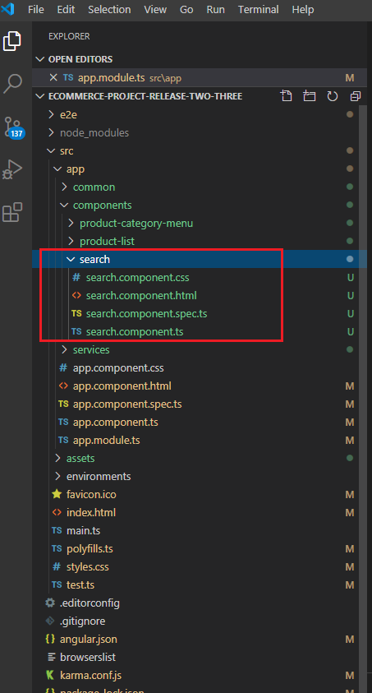

Tworzenie nowego modelu:

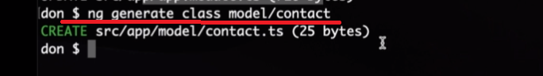

–

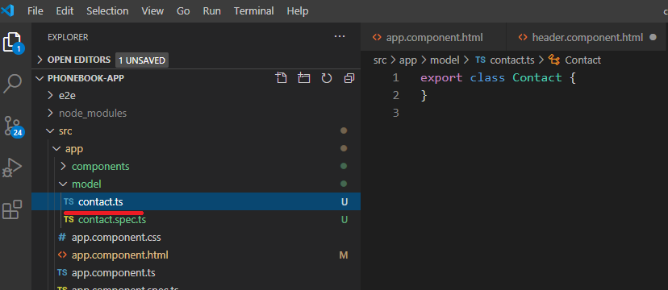

Tworzenie pipes:

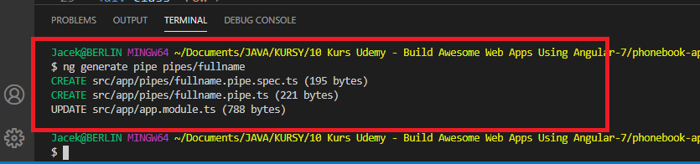

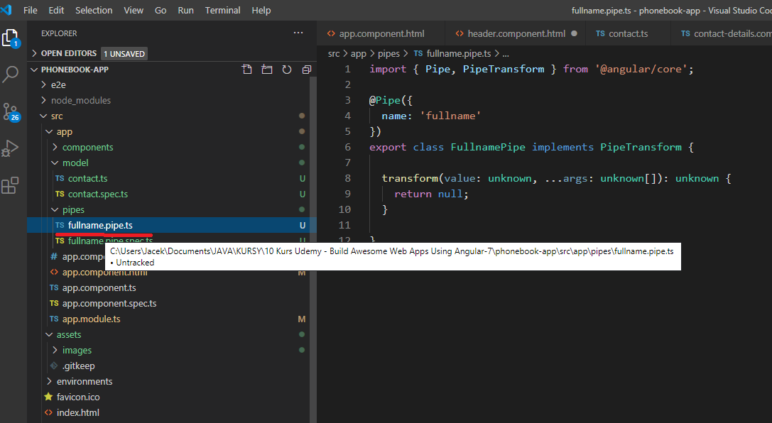

Tworzenie JSON-server

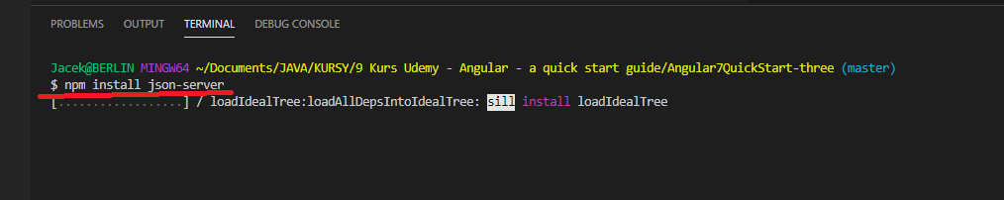

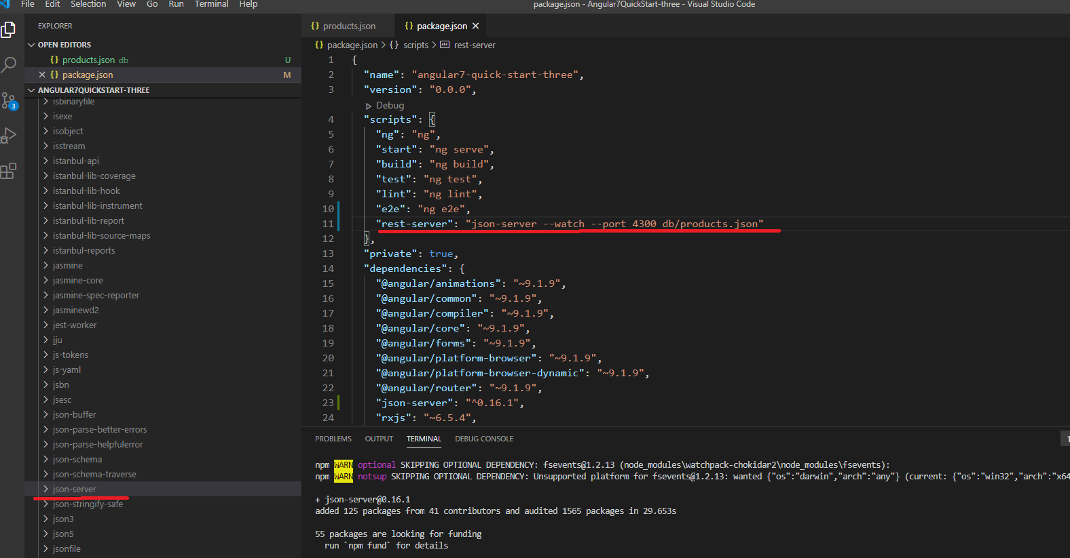

npm run rest-server

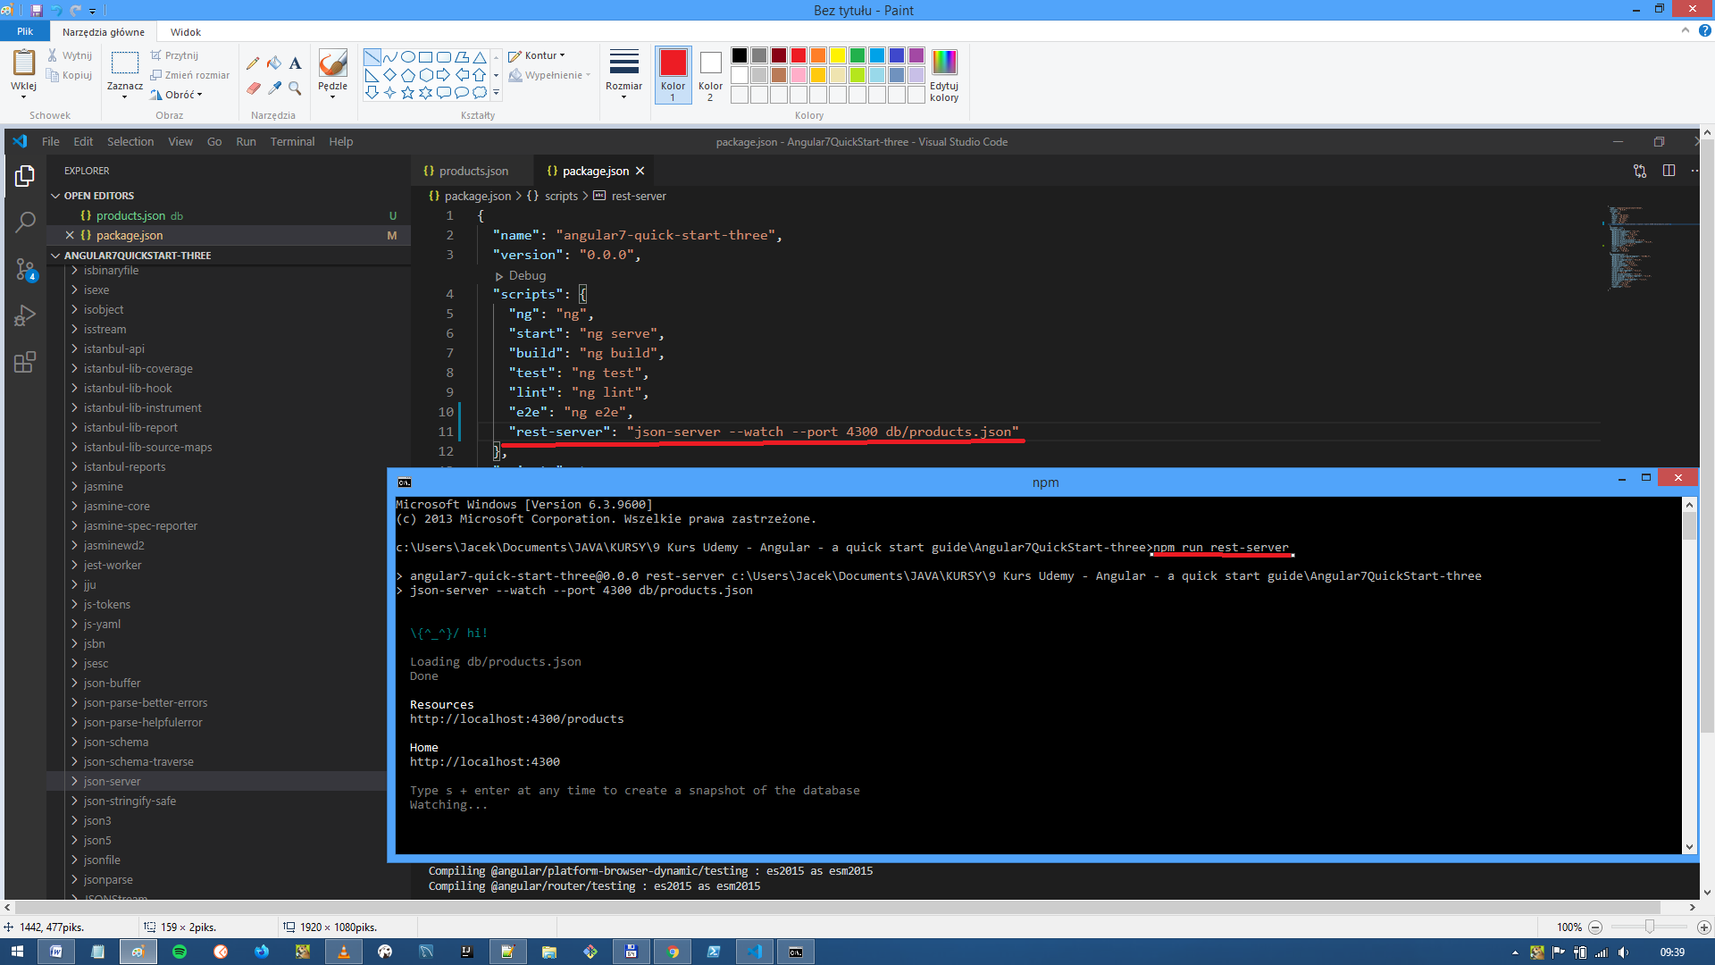

program:

c:\Users\Jacek\Documents\JAVA\KURSY\10 Kurs Udemy - Build Awesome Web Apps Using Angular-7\**phonebook-app-sekcja-eigth**

npm run json-server

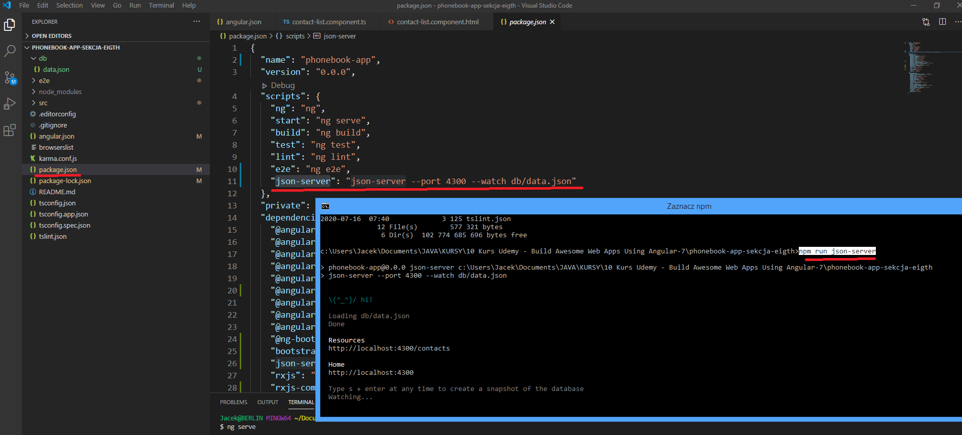

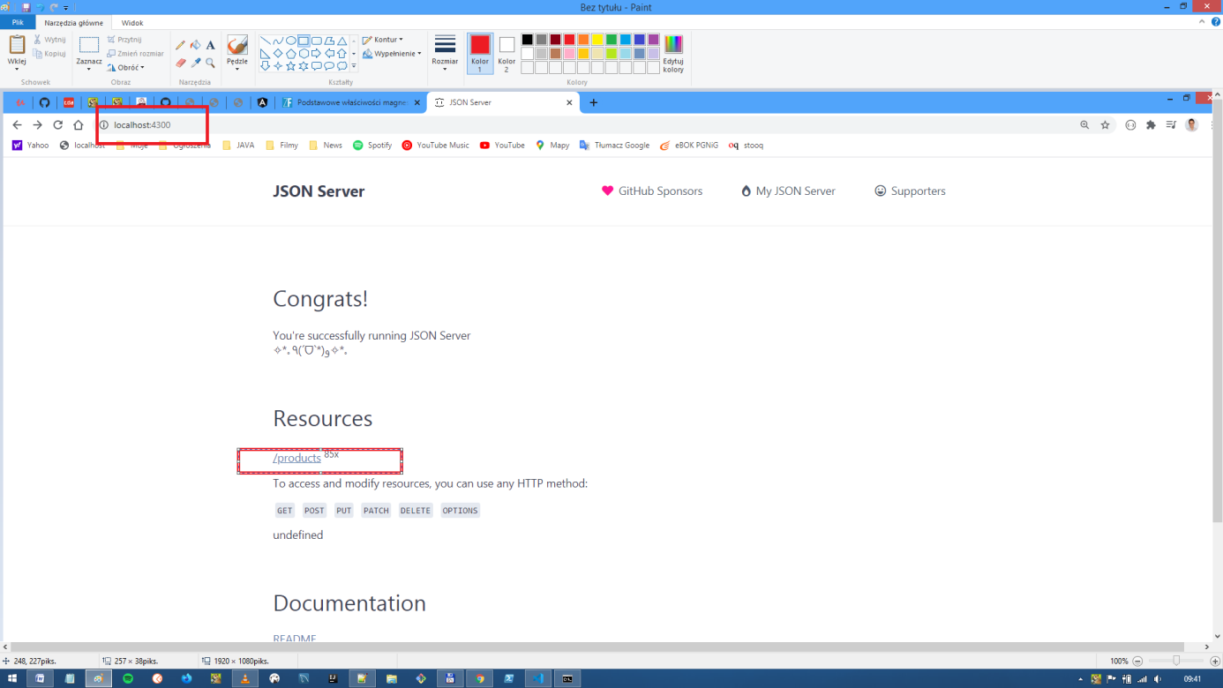

Custom pipes

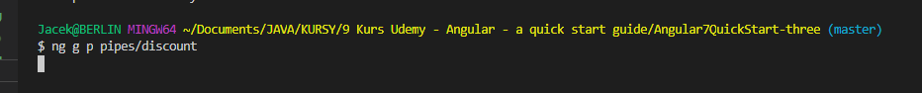

# MS Windows - Install Development Tools

In this guide, we will install the following development tools

* Visual Studio Code

* node

* npm

* tsc

## Install Visual Studio Code

Visual Studio Code is a general purpose IDE that support many programming languages. Visual Studio Code has built-in support for TypeScript.

1. In a web browser, visit https://code.visualstudio.com/

2. Follow the link to download Visual Studio Code for MS Windows

3. Run the Installer

4. Follow the steps in the Installer

## Install Node

Node is the the runtime environment for executing JavaScript code from the command-line. By using Node, you can create any type of application using JavaScript including server-side / backend applications.

In this course, we'll use Node to run applications that we develop using TypeScript and Angular.

1. In your web browser, visit https://nodejs.org/en/download/current/

2. Select the **Windows Installer (.msi)** for your system (32-bit or 64-bit)

3. Run the Installer

4. Follow the steps in the Installer

5. Open a **Command Prompt** window to verify the node installation

6. In the **Command Prompt** window, type the following command:

```bash

node --version

```

If the installation is successful, you will see the version number

> Note: The Node installation also includes npm (Node Package Manager).

3. Verify npm is installed

```bash

npm --version

```

If the installation is successful, you will see the version number.

> Note: node will have a different number than npm. This is similar to a different Java JDK version number compared to Maven version number.

>

> In this example, node is similar to the Java JDK. And npm is similar to Maven.

## Install tsc

tsc is the TypeScript compiler. We use tsc to compile TypeScript code into JavaScript code. We can install the TypeScript compile using the Node Package Manager (npm)

1. In your **Command Prompt** window, enter the following command

```

npm install -g typescript

```

The "-g" installs this as a global package. The TypeScript compiler will be available to all directories for this user.

You will see something similar to

```

C:\Users\luv2code\AppData\Roaming\npm\tsserver -> C:\Users\luv2code\AppData\Roaming\npm\node_modules\typescript\bin\tsserver

C:\Users\luv2code\AppData\Roaming\npm\tsc -> C:\Users\luv2code\AppData\Roaming\npm\node_modules\typescript\bin\tsc

+ typescript@3.6.3

added 1 package from 1 contributor in 3.188s

```

2. You can verify the installation

```bash

tsc --version

```

If the installation is successful, you will see the version number.

That's it! You have successfully installed the development tools: Visual Studio Code, node, npm and tsc.

## Troubleshooting

### Permissions Issue with tsc

1. If you get the following error when executing tsc command using PowerShell:

```bash

tsc : File C:\Users\johndoe\AppData\Roaming\npm\tsc.ps1 cannot be loaded because running scripts is disabled on this system. For more information, see about_Execution_Policies at https:/go.microsoft.com/fwlink/?LinkID=135170.

At line:1 char:1

+ tsc sample-datatypes.ts

+ ~~~

+ CategoryInfo : SecurityError: (:) [], PSSecurityException

+ FullyQualifiedErrorId : UnauthorizedAccess

```

2. You can resolve this issue with the following steps:

1. Run Visual Studio Code as **Administrator**

2. In the Terminal Window of Visual Studio Code, run `Set-ExecutionPolicy RemoteSigned` on PowerShell.

*This troubleshooting tip was contributed by **Fabio Gomes Sakiyama**. Thanks Fabio!!*

### Typescript: 'tsc' is not recognized as an internal or external command

1. If you get the following error when executing tsc command:

```bash

Typescript: 'tsc' is not recognized as an internal or external command

```

2. You can resolve this issue with the following:

1. Add the npm installation folder to your "user variables" AND "environment variables"

*This troubleshooting tip was contributed by **Chris**. Thanks Chris!!*

---

&copy; 2020, [luv2code LLC](http://www.luv2code.com) - All rights reserved.